WISE (Operating as Women in Energy) 26th Annual Golf Networking Event
Please support women in industry as we kick off our 26th annual golf networking event. We are a non-profit organization supporting Women who work in Energy and the ACF (Alberta Cancer Foundation). Diversity, Equity and Inclusiveness (DEI) is important to us, and we invite women and men from across the energy industry to join us for a non-competitive, fun event.
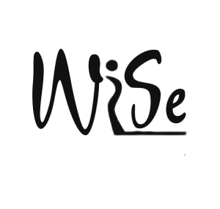 | - Sept 3rd, 2026  - 8 am arrival  - 9 am Shotgun Start  - Texas Scramble  - Buffet Lunch will be provided  - The Lynx Ridge Golf Club  - 8 Lynx Ridge Blvd NW, Calgary, Alberta, T3L 2M3  - Theme: Famous Four-some
Sponsorship Levels  All levels include prominent signage at front lobby & luncheon social!  HOLE SPONSOR $500  - Meet all players as they play through  - Recognition for best hole gimmick  SILVER $750  - 1 paid golf registration including lunch  - 2 additional luncheon invitations  - Value $250  GOLD $1200  - 2 paid golf registrations including lunch  - 3 additional luncheon invitations  - Value $480 |  | PLATINUM $1700  - 4 paid golf registrations including lunch  - 3 additional luncheon invitations  - Value $960  19th HOLE SPONSOR $500  - Signage on raffle prize
Thank you for sponsoring this important event to support and recognize Women who work in the energy industry.
Sponsorship level
Company Name
Address
Company Website
Contact Name
Phone Number
Email
Comments

Please send completed forms and send your corporate logo to Sue Carr (sue.carr@katalystdm.com) or Joanne Poloway (joanne.poloway@sigmaex.com)
We accept E-transfers to WiseGolf2000@gmail.com

